CSCI 236 Chapter 9 Top-Level Design:
First-level structure chart for racquetball simulation.
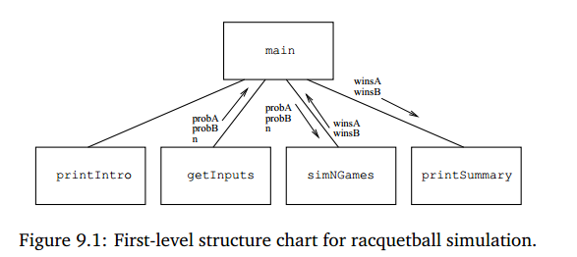
Level 2 structure chart for racquetball simulation.
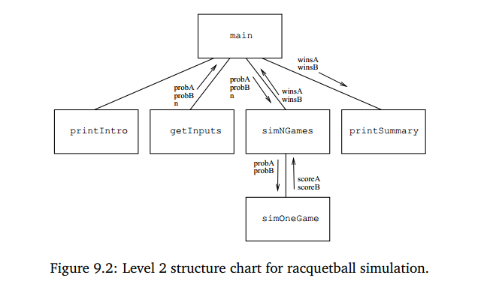
Level 3 structure chart for racquetball simulation.
